What is splunk ?
Splunk is tool to analyze real time logs
Splunk provides an interface to analyze the logs produced by the application in microservices environment
Why splunk ? Assume we have multiple microservices and all are publishing to the same log file as in below
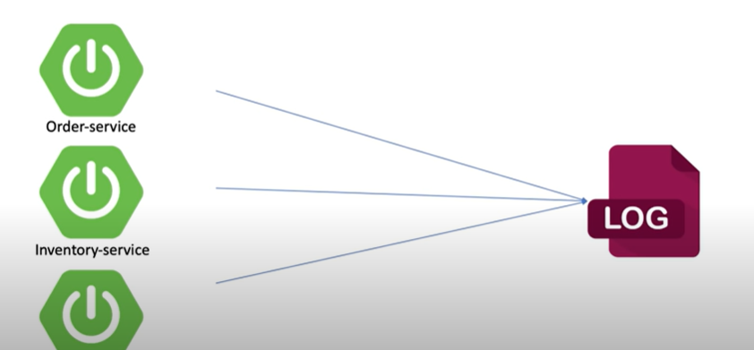
Now if there is an exception in any of the services then it becomes difficult to analyse the logs. To overcome this splunk is used. Splunk segregates logs by using index. Hence we can now forward the logs to splunk using these index
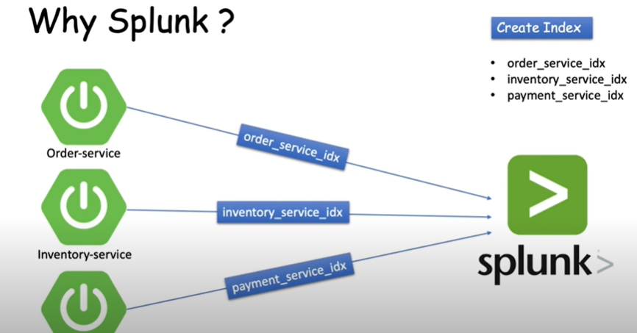
We can use log4j to write the logs. But splunk is running on different server then how to provide this information. This can be resolved by using customization XML file called log4j-spring.xml where we can provide the details like credentials, address etc
